Prayer Guide for the week 22 to 28 May
“I felt my heart strangely warmed…I felt I did trust in Christ, Christ alone, for salvation; and an assurance was given me that he had taken away my sins, even mine, and saved me from the law of sin and death.”
John Wesley

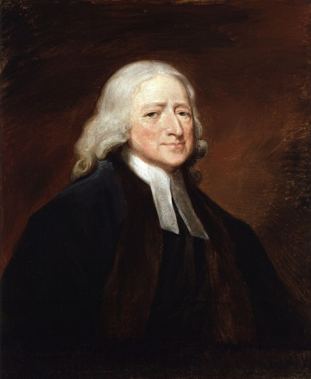
On Wednesday 24 May, we will be celebrating Aldersgate Day, the day in 1738 John Wesley felt his heart strangely warmed. Earlier that Sunday, he had preached a sermon that had been shot down by his congregation. That evening, though he felt depressed he decided to go to the meeting at the Aldersgate church. That night, he was filled with the Holy Spirit and his preaching came alive and inspired him in his work to bring the gospel to all. His work and method of teaching the Gospel eventually led to the formation of our Methodist Church.
On Wednesday evening we will celebrate Aldersgate day with hymns, mainly composed by John and his brother Charles, led by Rev Mark Stephenson. Come and join us!
This week also sees the start of Synod in the Wynberg circuit. We pray for:
- Our Bishop and ministers attending, including Ross, and others for wisdom in their discussions.
- The work of the “Top Table”, management team, and the Resolution and listening committees.
- Our circuit ministers, circuit stewards and other delegates as they meet.
- That the conversations and the decisions they make will be in line with Your will for mission in our churches.
We pray for:
- Our church, for the many activities surrounding our centenary,
- The service of hymns on Wednesday
- Our country and our leaders; for our president and parliament, for the right decisions and decisive action on the many crises facing our land.

