Prayer Guide for the week 8 to 14 May
Look at the birds of the air; they do not sow or reap or store away in barns, and yet your heavenly Father feeds them. Are you not much more valuable than they? Matthew 6:26

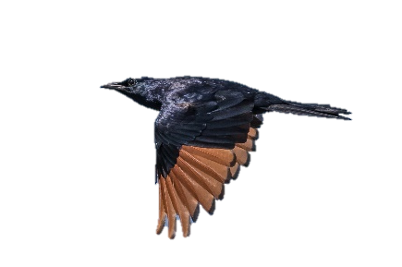
Yesterday morning, we had, a feathered visitor in church! It flitted around the roof space and, of course, our attention was on the starling instead of worship. Ross had some serious competition in the beginning, but fortunately, the starling got away through one of the windows.

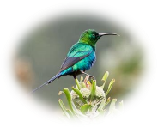
We give thanks to God for the beauty of his creation; for the many species of birds we have, from the beauty of the tiny sunbirds to the plumage of the Knysna Turaco.

We are much more valuable to God than birds are! We so often forget that we all are, be we the King of England or the person who scratches in your bin on rubbish day. In our church calendar, May is designated as Warmth month, and we have already started collecting for the poor and homeless, that they may have something to wear or blankets to sleep under this winter. Please consider donating.

Lord, we pray for
- The many Societies where warmth month is recognised, for large collections of blankets, clothing or shoes.
- The distribution of these items, that it may go smoothly in all cases and go to the neediest people.
- For homeless people who, as winter approaches, sleep in doorways, makeshift shelters and pup tents throughout our city. They have so little to provide themselves with shelter from the rain and cold.

We thank you, Lord, for
- The beauty and sound of the birds around us, for the wildlife in our gardens and mountains.
- For your creation
- For our church, our centenary of existence
- For Ross and Liza serving our community in Pinelands
