Prayer Guide for the week of 23 to 29 October
"Is prayer your steering wheel or your spare tyre?" Corrie ten Boom

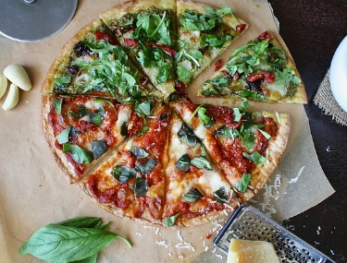
A few days ago, I opened my emails and discovered that October is World Pizza Month. Another told me that it is World Smile Month. I then googled October and found it contained either a world day or a world month for such important events such as Breast Cancer and Non-Violence, but also for Older Persons, Habitat, No Beard Day and Chocolate Cupcake Day.

For us, As Christians, we have very special and meaningful days such as Good Friday, Easter Sunday, Ascension, and Christmas. What is most important, though, is every day and every minute we can be in communication with our Lord. We don’t need special months or days or times to speak to God; He is there and wants us to be in conversation with him.

Conversation implies two-way communication, but sadly, we often feel it’s a one-way discussion with us doing the discussing. If you have not already joined one of the groups following Pete Greig’s course on “God on Mute” please consider doing so. You can phone the church office for times and places of group meetings.

This week, please pray:
- For a speedy end to the Israeli-Hamas conflict.
- For those doing all they can to bring much needed food and medical supplies into Gaza.
- For the international powers (including South Africa) trying to broker peace in the area. For Israel and Hamas to be prepared to accept a peace deal.
- For the elderly, the women and the children, who have lost family, and loved ones.
- For the doctors and healthcare workers who do all they can with limited resources to care for the injured and dying.
- We also remember Ukraine and the many other conflicts raging around the world today.

“MUCH, MUCH MORE in 2024”

